Learning Plan Builder — Build Guide
Reference build: learning_plan_builder_demo.html (working logic — port buildPlan / chainPre / twoWeek as-is). Data: Grade5_LearningPlan_Inputs.xlsx. Validate by running the same student on both builds — outputs must match.
1 · Student
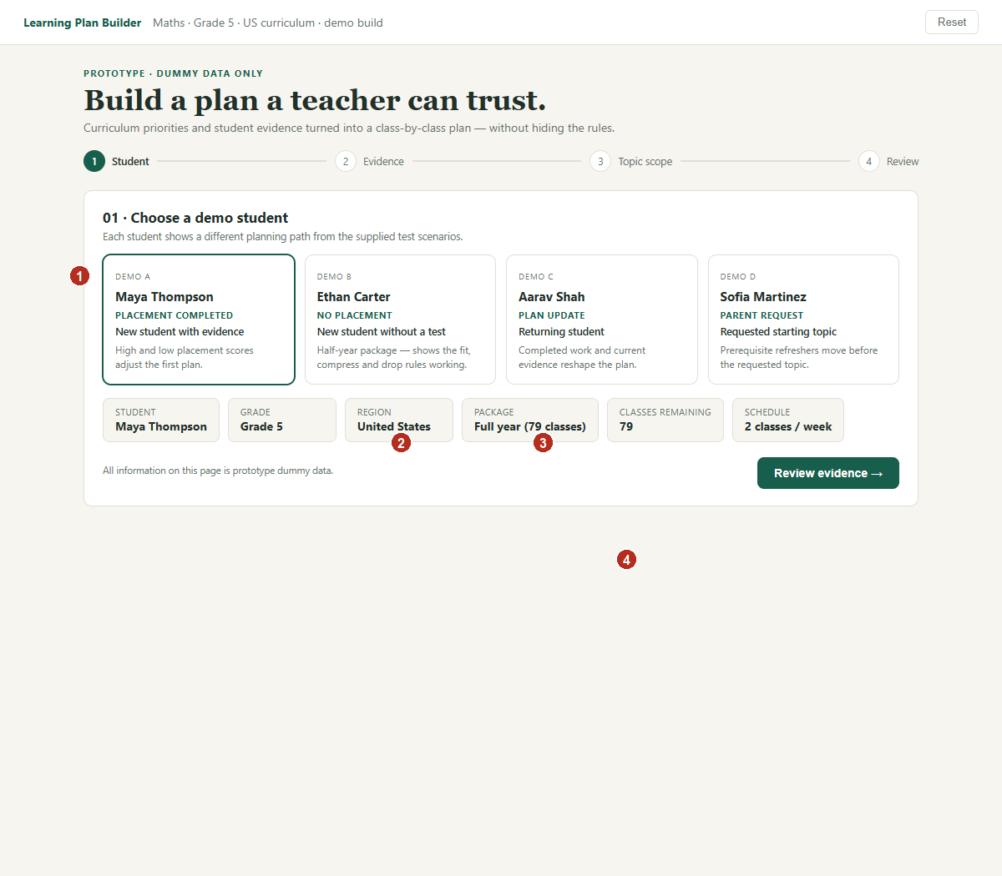
① 4 selectable demo students. Selecting one resets all edits/state.
② Show package label from data ("Full year (79 classes)" / "Half year (40 classes)"). classes_remaining always = classes left in the purchased package — same field for new and returning students.
③ classes_remaining drives all capacity math. Also show classes/week (default 2) — used only by the 2-week tab.
④ CTA disabled until a student is selected. No plan generation happens on this screen.
2 · Evidence
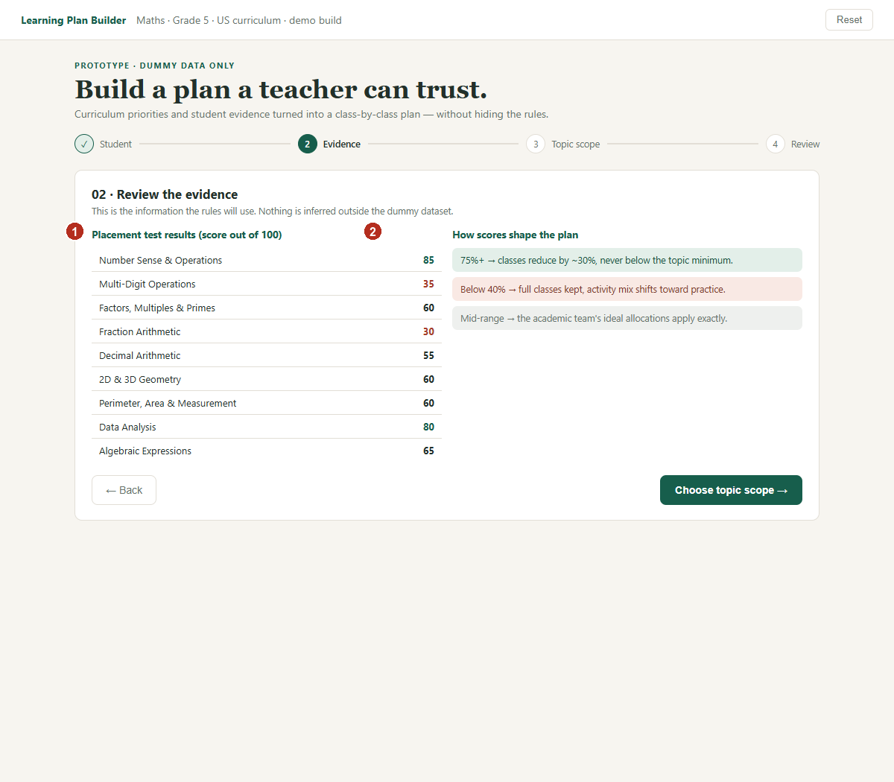
① If placement taken: list score (0–100) per topic. Highlight ≥75 green, <40 red.
② Static rules panel. Logic applied later in the engine: score ≥75 → classes = max(min, ceil(ideal×0.7)); score <40 → keep ideal classes, shift easy:practice 15 points toward practice; else ideal as-is.
Variants: no test → single info line. Returning student → two panels (below): completed topics with classes used vs planned + saved count; current-topic evidence lines (ok/bad) — these feed the Mentor tab. Parent request → dropdown of topics; store requested_topic_id.
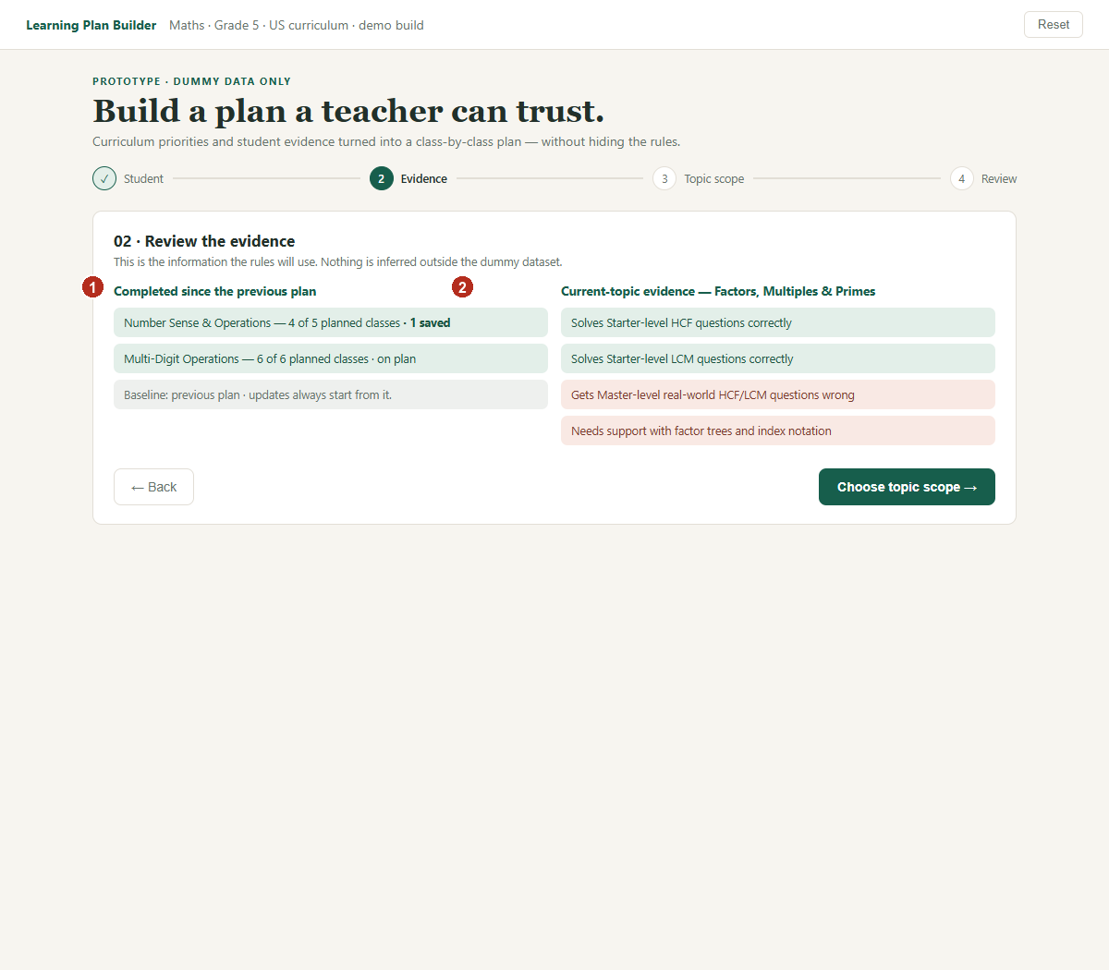
① completed[]: {topic_id, classes_used}. saved = Σ(ideal − used) where positive; add back to the class pool.
② current topic: {topic_id, classes_used, lo_levels[]} where lo_levels ∈ {master, stuck, not_attempted} per learning objective.
3 · Topic scope
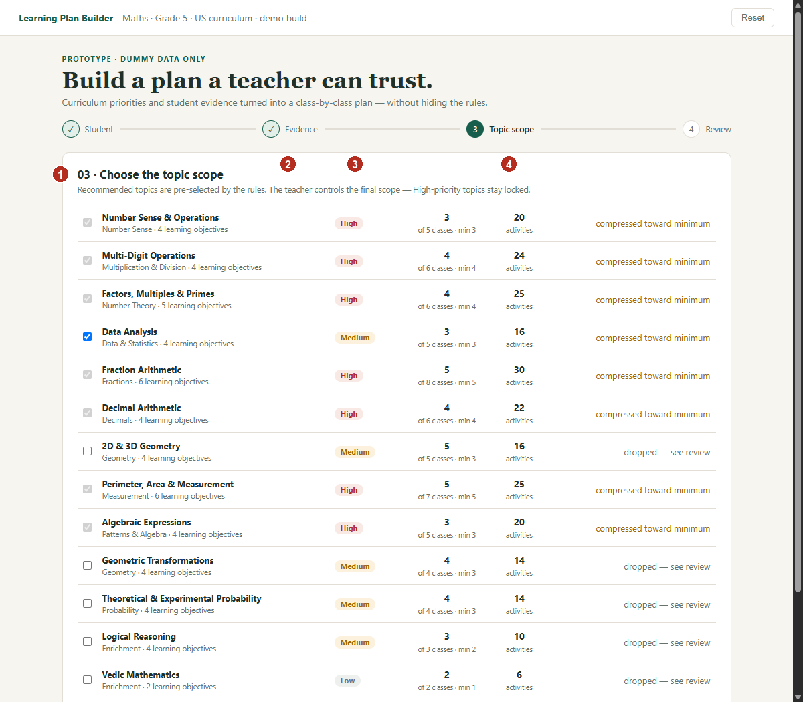
① Checkboxes pre-checked from engine output. High-priority topics: checkbox disabled (locked in). Un-checking = manual removal → sets manual_override flag.
② Priority pill from data (H/M/L).
③ Show current ÷ ideal classes and min. current comes from the engine (placement/compression applied).
④ Status text column = engine flags verbatim: required / recommended / compressed toward minimum / reduced · placement N% / dropped. Never hide the reason.
After any manual change show: "Manual change recorded — automatic updates stay paused until the next class data arrives." Persist manual_override until a class update occurs or until teacher clicks "Reset plan" to restore automatic engine calculations.
4 · Review — capacity + sequence
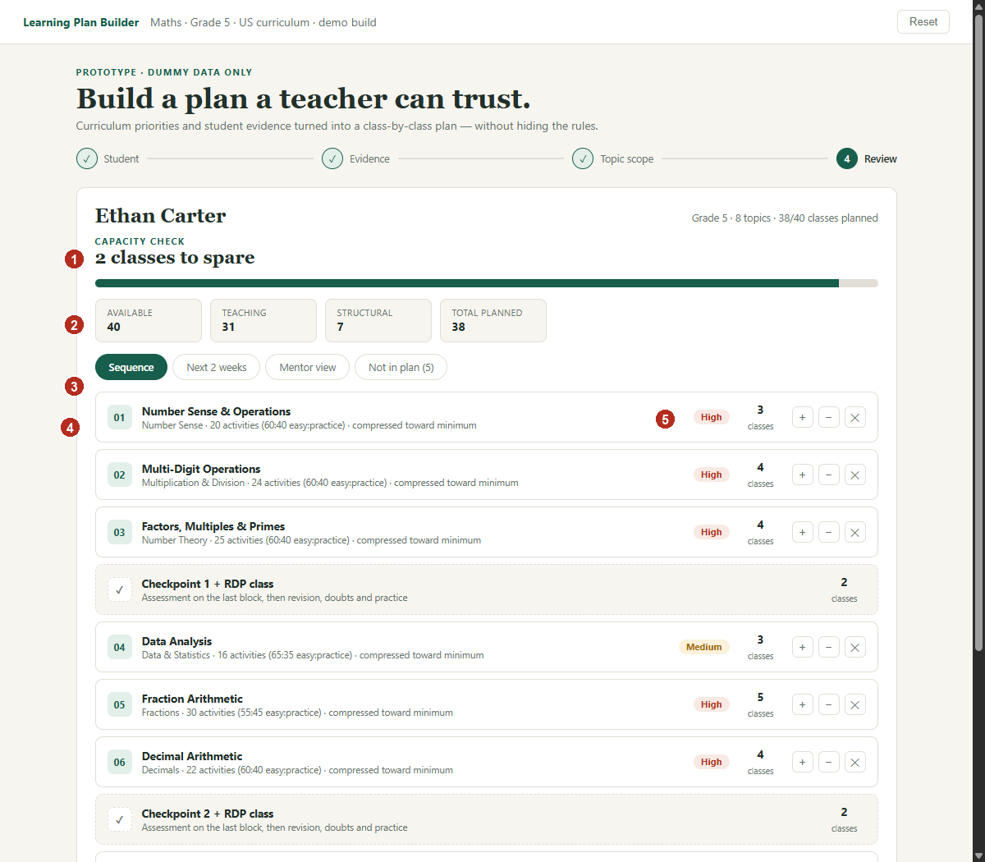
① Headline = |planned − available| + "class(es) to spare" / "class(es) over" (uses singular "class" when count is 1). Bar fill = planned/available, red when over.
② Chips: available · teaching (Σ topic classes) · structural (checkpoints×2 + PTM) · total. Recompute on every edit.
③ 4 tabs, same plan object: Sequence / Next 2 weeks / Mentor view / Not in plan (only when drops exist, show count).
④ Sequence row: topic, family, activities + easy:practice, flags, priority pill, classes. Insert "Checkpoint N + RDP (2 classes)" row after every 3 topic rows, up to the structural checkpoint count. Refresher rows get an amber left border + "prerequisite refresher" label (exempt from capacity compression).
⑤ Edits: +/− classes clamped to [min, ideal+2]; ✕ removes topic. Every edit → re-run engine, tag row "teacher edited", set manual_override.
If spare ≥ 10 classes: show note "Spare classes reserved for Revision / School Help" — do not stretch topics. If still over after compression+drops: red warning "High-priority topic needs a manual decision" — never auto-drop High.
4a · Not in plan
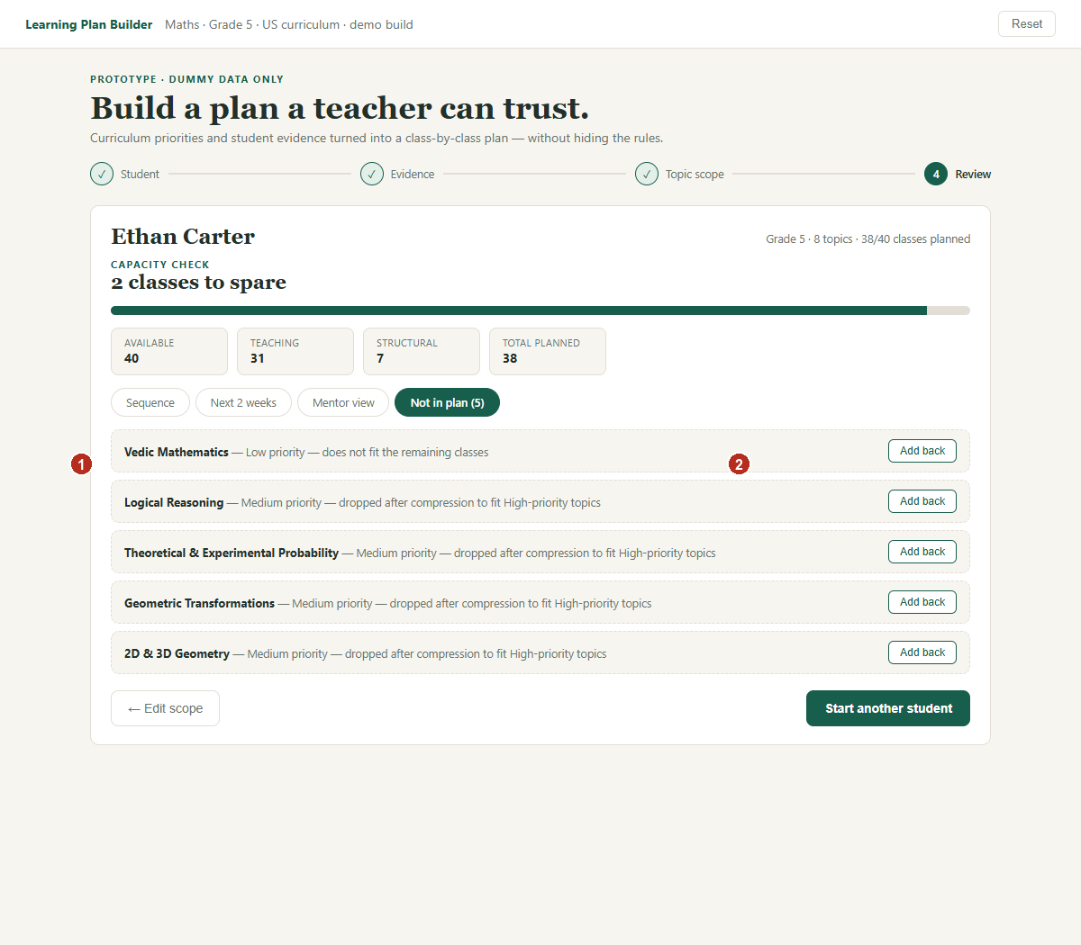
① One row per dropped topic + reason string from the engine (Low dropped first, then Medium, latest sequence first, only after compression).
② "Add back" re-inserts the topic (exclude it from future auto-drops), re-runs the engine — capacity may go over; show the warning rather than blocking.
5 · Mentor view tab
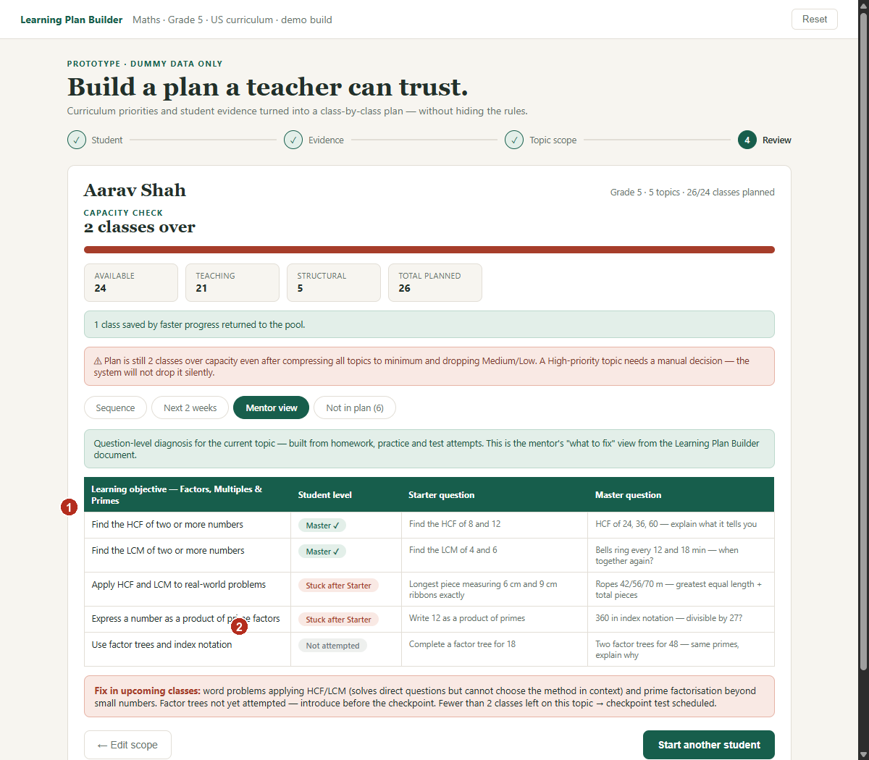
① Table for the current topic: one row per learning objective — LO name, level pill, Starter question, Master question. Questions come from the question-guideline data (3 sample topics available); if a topic has no questions yet, show a fallback line.
② Level pill from lo_levels: master → green "Master ✓", stuck → red "Stuck after Starter", not_attempted → gray. New students have no attempt data → render the same table without the level column + info line "shown as teaching guidance".
③ "Fix in upcoming classes" panel: generated text from the stuck/not-attempted rows + test note when the topic has <2 planned classes left.
6 · Next 2 weeks tab
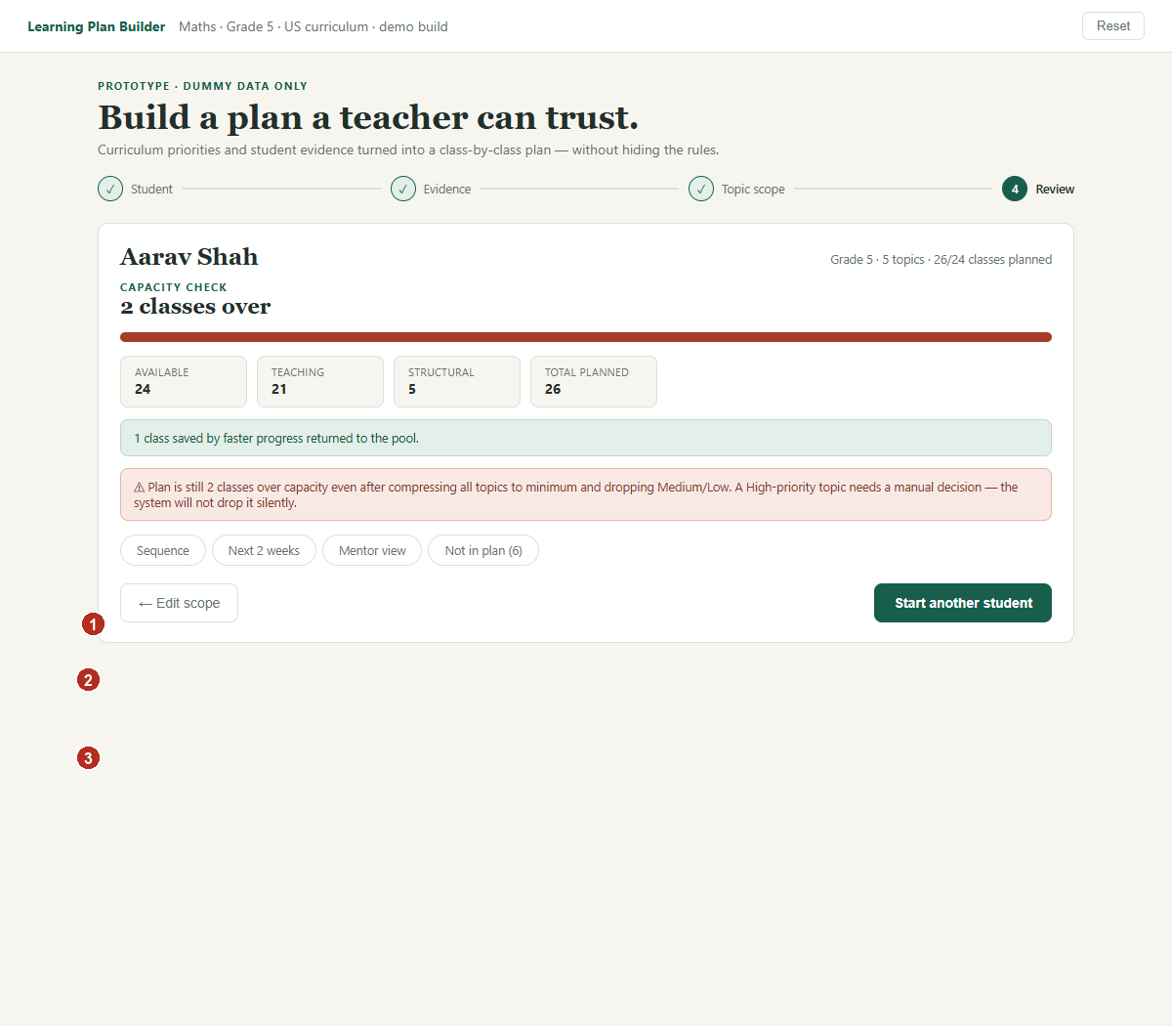
① Window = classes_per_week × 2 classes taken from the front of the sequence.
② One card per class: topic, one LO per class (walk the topic's LO list), activities ≈ round(topic.activities ÷ topic.classes).
③ When a topic has <2 planned classes remaining at that point → amber card + "Topic test scheduled".
7 · Parent request sequencing
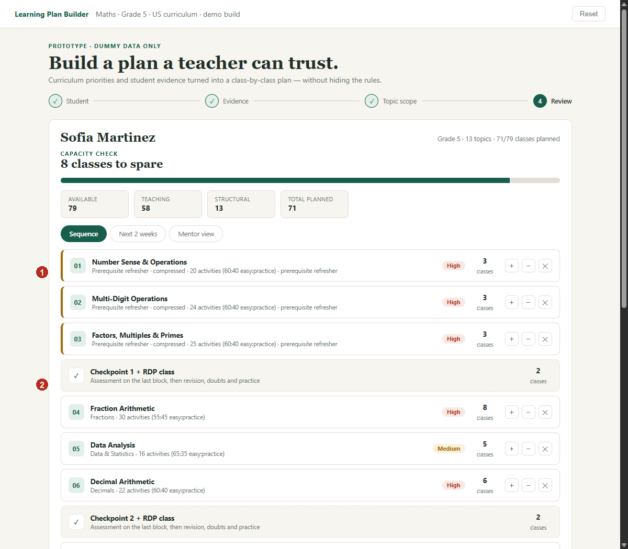
① Walk requested topic's prerequisites transitively; every incomplete one becomes a refresher scheduled first, in curriculum order, at ceil(ideal÷2) classes (min 1). Refreshers are exempt from compression.
② Then the requested topic at full classes, then all remaining topics in normal curriculum order. Nothing is deleted; normal fit rules run on the reordered list.

Engine order of operations (port from reference build)
1 candidates = grade topics − completed − manual removals, in curriculum seq, cls = ideal
2 returning: current topic cls = max(min, ideal − used); saved classes return to pool
3 placement: ≥75 → cls = max(min, ceil(ideal×.7)); <40 → flag practice-heavy, easy −15
4 parent request: refreshers (transitive prereqs, ceil(ideal/2), min 1) → topic → rest in seq
5 structural = checkpoints(min 2, max 5, ≈ topics/2.5) ×2 + PTM(3 full-year / 1 smaller)
6 while over capacity: compress cls→min, lowest priority + latest seq first (skip refreshers)
7 still over: drop L then M (latest seq first), recompute structural as count falls
8 still over: keep plan, show red warning — NEVER auto-drop High
9 struggling topic: max +2 classes; no topic ever auto-reaches 0 classes
Bounds everywhere: min ≤ classes ≤ ideal+2. Recompute the whole plan after any input or edit — no partial patches.
Data sources
Grade5_LearningPlan_Inputs.xlsx → Sheet 1: topic id/seq/priority/prereqs/ideal/activities/easy% (add min-classes column from reference build data block). Sheet 2: LO names. Sheet 5: Starter/Master questions (3 topics). Sheet 4: the four scenario inputs — these are the acceptance tests: same input on the reference build and your build must produce the same plan.

